Coupled SUPG NEAT Parameter Tuning:

Several parameter tuning tests were conducted in order to optimize experiment results, and efficiency in terms resource allocation and computation time.

In order to determine the impact specific of NEAT parameters, multiple example controllers were evolved for a varying number of generations (between 50 and 300), with their impact on controller fitness being observed through terminal output. This specifically relates to the NEAT parameters concerning connection add/remove probabilities and contributes to why the chosen values were used.[1]

This process was also used for other NEAT parameters. For example, it was observed that the mean genetic distance between genomes is 3.5 on average with a standard deviation between 0.2 and 0.3. Accordingly, a compatibility threshold of 3.8 was used to maintain a degree of speciation.

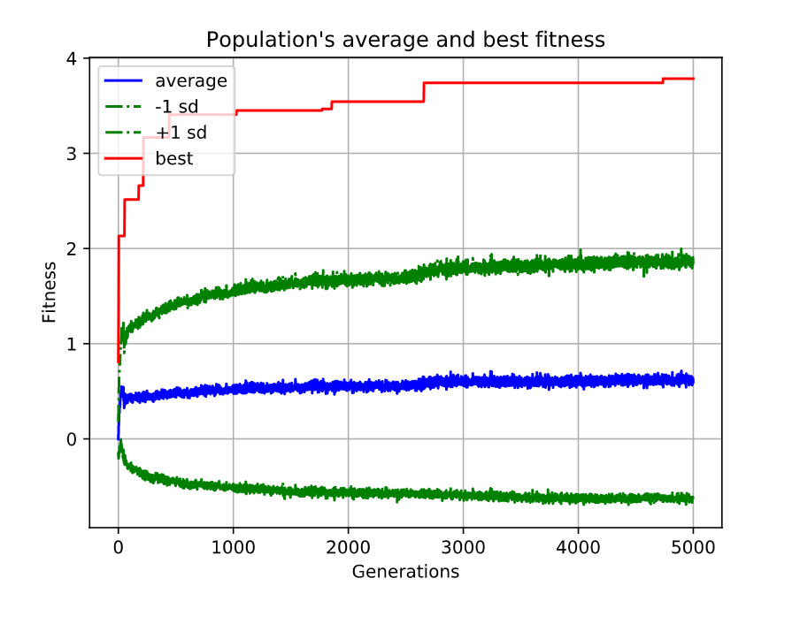Lastly, a 5000-generation evolution trial of the coupled SUPG was run in order to observe the point at which its fitness curve would display significant diminishing returns. This process resulted in 2800 generations being used for each experiment trial, with the rationale that this value produced an optimal fitness when taking resource use (time spent evolving) into account. For reference, the 5000-generation trial took approximately x hours of computation time. This graph can be found below:

Figure : 5000 Generation Fitness Graph

1. The chosen values were determined through a combination of the parameter tuning process outlined above, as well as the existing research conducted by Risi et al. [27] and Tarapore et al. [43]